TEST OVERVIEW
Concern Index | 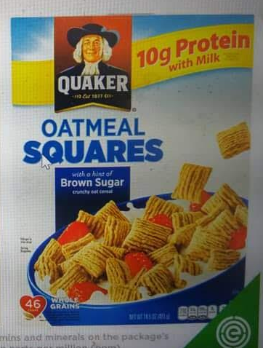  [Example product image size]
[DELETE --->>First calculate each safety rating on page 2 under “DETAILED TEST RESULTS”, take the highest result”]

89
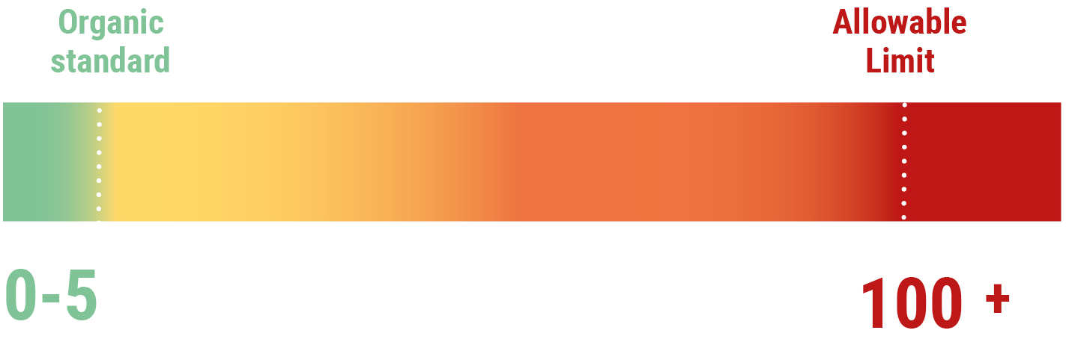

Product Name |  | Place of Purchase | [check on admin panel]
Brand |  | Test type | Pesticide testing for ~420 contaminants
Date of Test | MM/DD/YYYY | Test Method | AOAC 2007.01, GC-MS, LC-MS
Date of Purchase | MM/DD/YYYY | Lab Name | AGQ Labs

DETAILED TEST RESULTS

Pesticide contaminant | Amount Detected | MRL  (mg/kg (food))  (USA) | MRL  (mg/kg (food))  (EU) | Tolerable Concentration Limit  (TCL)  (mg/kg (food)) | Food Concern Index
[Name of pesticide] | [Amount of pesticide detected] |  |  | [Allowed limit from calculator for each chemical] | [FCI score for each chemical]
 |  |  |  | [Allowed limit from calculator for each chemical] | [FCI score for each chemical]
 |  |  |  | [Allowed limit from calculator for each chemical] | [FCI score for each chemical]
 |  |  |  | [Allowed limit from calculator for each chemical] | [FCI score for each chemical]

WHAT DO THE RESULTS MEAN?

>>DELETE --->> If the food got a Concern Index number higher than 0

The food got a Concern Index of [insert number]; the Food Concern Index benchmarks the test results from the lab against the tolerable daily intake for each contaminant detected. Read more about allowed levels and our Concern Index on our FAQ.

>>DELETE --->> Because one or more pesticide contamination had an FCI of 100+

0
FCI
100
85
5
DELETE

[Name of pesticide(s)] was/were detected in the food sample at [number] mg/kg. Our calculations, which are based on guidance issued by the EFSA, EPA and other authorities, show that this sample is over what might be acceptable for an average [choose > baby/adult] to consume.

As the level detected was very high on the Food Concern Index, we calculate that eating a portion of it may expose you to more than the tolerable daily intake for this/these contaminants. Therefore we recommend avoiding or severely limiting consumption of this product.Continued regular exposure to pesticides may lead to many health problems including cancer and infertility problems and birth defects, dependant on the individual and the pesticides present.

>>DELETE --->> Because ___number__ of pesticide contaminant(s) was detected and came close to failing the test

0
FCI
100
85
5
DELETE

[Name of pesticides] was/were detected at levels that resulted in an FCI score of [insert scores]. This/These scores are high for [Name of pesticides], which indicates if you eat a standard portion of this food, you would come close to reaching your tolerable daily limit of the contaminant(s) we found, therefore you may want to avoid this food. >>DELETE --->> if the “allowable limit” food was calculated for an adult, include this sentence: This result might be a special consideration if you or your family members are in a vulnerable group, such as infants, elderly, or those with chronic health conditions.

>>DELETE --->> One or pesticide contaminant was detected, but was well under the limit

0
FCI
100
85
5
DELETE

[Name of pesticide] was/were detected at levels well within the tolerable concentration levels according to our calculations based on guidance issued by the EFSA, EPA and other authorities. We calculate that if you ate a standard portion of the food you are unlikely to go over the tolerable daily intake for this/these pesticide(s). [NAMES OF PESTICIDES THAT SCORE LESS THAN 50], detected at [WRITE THE AMOUNTS DETECTED], scored moderately low with an FCI score(s) of [write the scores]. [NAMES OF PESTICIDES THAT SCORE LESS THAN 50] score medium-high score which is slightly more concerning. However at these levels that the health of the general public are unlikely to be affected by the pesticides, but you may want to limit this food if you or your family members are in a vulnerable group, such as infants, elderly, or those with chronic illnesses.

>>DELETE --->> One or more pesticide contaminants were detected, but were all well under the limit

0
FCI
100
85
5
DELETE

[Name of pesticides] was/were detected at extremely low levels, according to our calculations is low on the Food Concern Index. This means that this food is considered not very contaminated and if you ate a standard portion you are unlikely to come close to exceeding the tolerable daily intake for this/these chemicals.

>>DELETE --->>Because none of the pesticide contaminants tested were detected (only choose this paragraph if no pesticides at all were detected)

0
FCI
100
85
5
DELETE

None of the 420 pesticides we tested for were detected, which means that according to these results, this food sample has passed and is considered not contaminated. Note, although the tests are extensive no test can rule out all possible contaminants. Our tests are selected by chemists to focus on the highest risk contaminants.

If this is a food you like and you feel it’s a healthy choice for you, go and treat yourself to more.

>> DELETE ---> Include some of the paragraphs below if the food is labelled as organic on the the lab report.

>> DELETE ---> CHOOSE this if food is organic--->Since the food being tested is organic, we should not see conventional pesticides present in the sample. If no pesticides detected CHOOSE this --->As no pesticide contaminants were detected this is just as expected. >> ADD this if organic and pesticide(s) was/were detected ---> Since contaminants were detected this not as expected. [list all pesticide name(s)] is/are not allowed in the production of organic food and therefore should not be present. However small amounts of contamination may come in from neighbouring farms.

[DELETE Use only if you haven’t included this sentence before and Food Concern Index is less than 25------->] Since the level of contamination is low, if you like this food, continue to enjoy it with confidence that it passed the tests.

>> DELETE ---> If the Concern Index number is 100 or 100+ use this statement. For any other Concern Index number DELETE this statement.

If you have been consuming this product and are concerned, we suggest you speak to your health care professional. If you have more of the same food, you may consider returning it to the manufacturer or place of purchase.

